Guideline to import/export dataflow NIFI

To import/export dataflow, we can use Template or NiFi Registry.

1. **Template**
2. **Creating a Template**

* To create a Template, select the components that are to be a part of the template, and then click the "Create Template" (Create Template) button in the Operate Palette

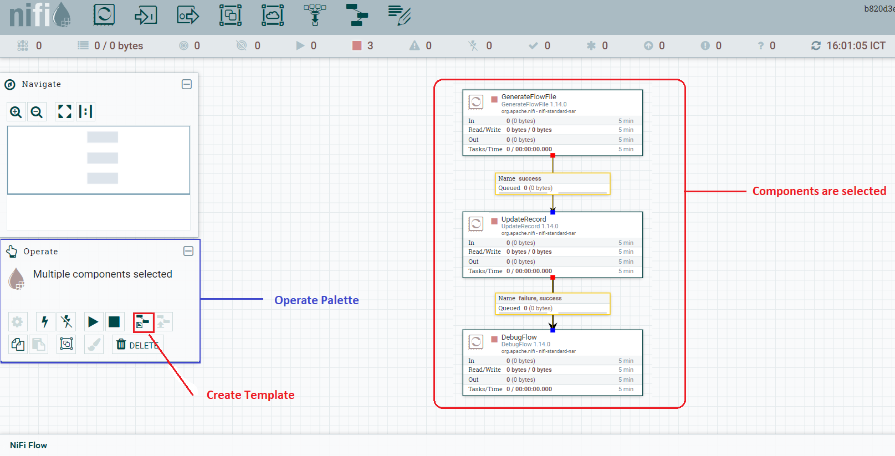

*Note: Clicking "Create Template" button without selecting anything will create a Template that contains all of the contents of the current Process Group. This means that creating a Template with nothing selected while on the Root Process Group will create a single Template that contains the entire flow.*

* After clicking this button, the user is prompted to provide a name and an optional description for the template. Each template must have a unique name. After entering the name and optional description, clicking the "Create" button will generate the template and notify the user that the template was successfully created, or provide an appropriate error message if unable to create the template for some reason.

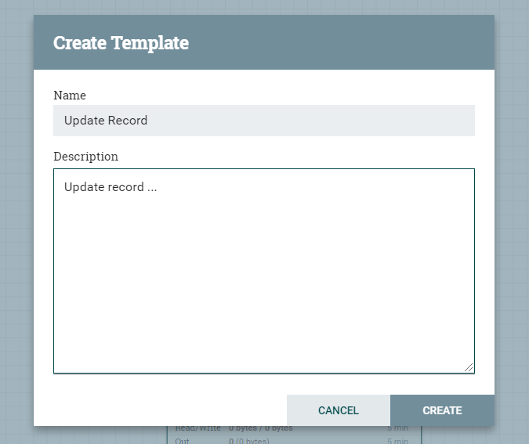

*Note: It is important to note that if any Processor that is Templated has a sensitive property (such as a password), the value of that sensitive property is not included in the Template. As a result, when dragging the Template onto the canvas, newly created Processors may not be valid if they are missing values for their sensitive properties. Additionally, any Connection that was selected when making the Template is not included in the Template if either the source or the destination of the Connection is not also included in the Template.*

1. **Exporting a Template**

* Once a Template has been created, it can be shared with others in the Template Management page. To export a Template, locate the Template in the table. The Filter in the top-right corner can be used to help find the appropriate Template if several are available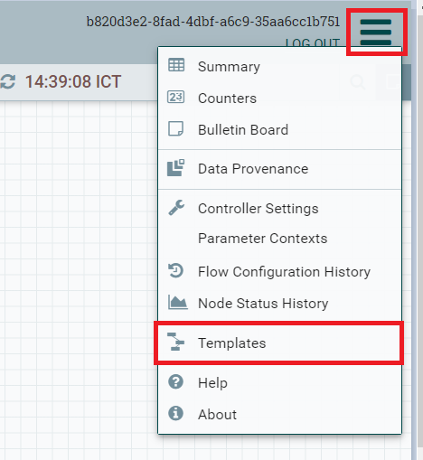
* Then click the "Download" button (Export). This will download the template as an XML file to your computer. This XML file can then be sent to others and imported into other instances of NiFi .

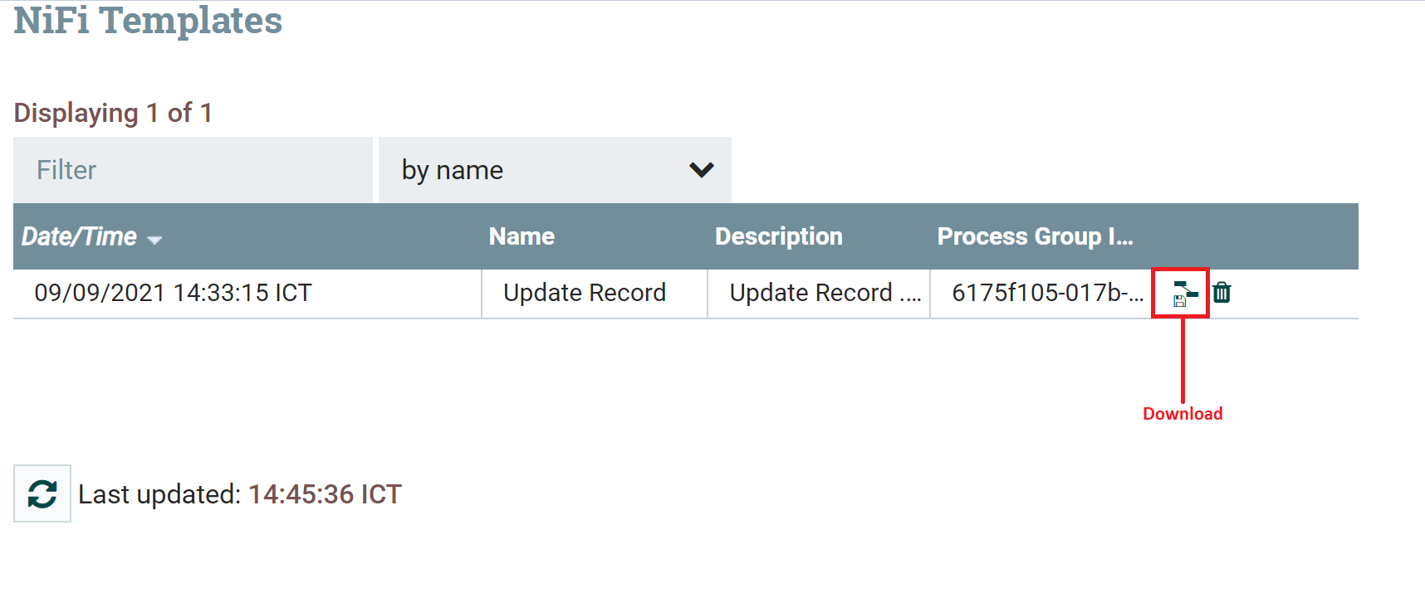

1. **Importing a Template**

* After receiving a Template that has been exported from another NiFi, the first step needed to use the template is to import the template into this instance of NiFi. You may import templates into any Process Group where you have the appropriate authorization.
* From the Operate Palette, click the "Upload Template" (Upload Template) button. This will display the Upload Template dialog. Click the find icon and use the File Selection dialog to choose which template file to upload. Select the file and click Open. Clicking the "Upload" button will attempt to import the Template into this instance of NiFi. The Upload Template dialog will update to show "Success" or an error message if there was a problem importing the template.

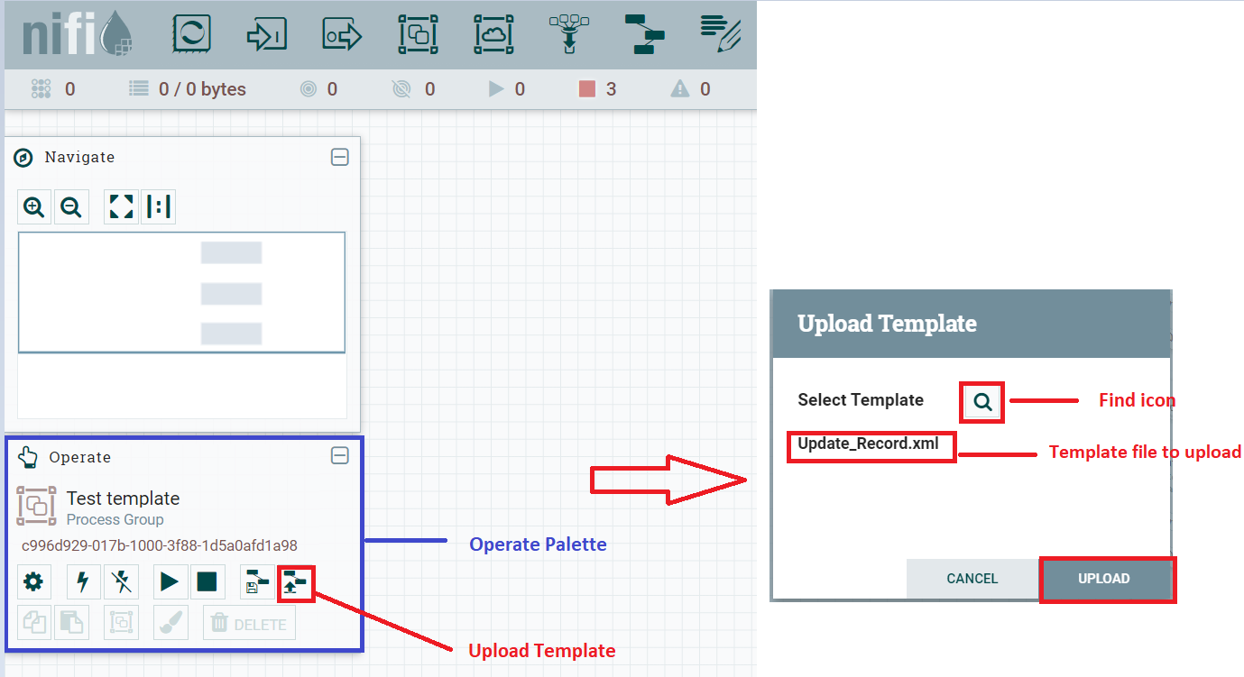

1. **Instantiating a Template**

* Once a Template has been created or imported, it is ready to be instantiated, or added to the canvas. This is accomplished by dragging the Template icon ( Template ) from the Components Toolbar onto the canvas.
* This will present a dialog to choose which Template to add to the canvas. After choosing the Template to add, simply click the "Add" button. The Template will be added to the canvas with the upper-left-hand side of the Template being placed wherever the user dropped the Template icon.

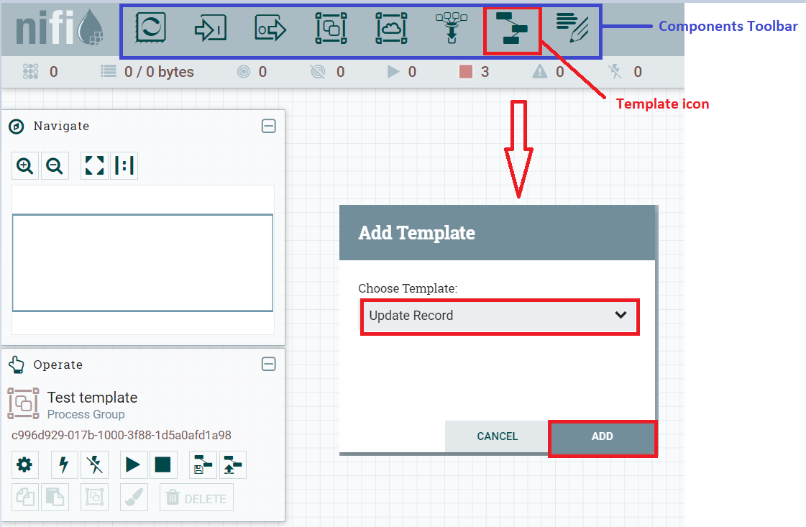

1. **NiFi Registry**
2. **Case 1**

* **Exporting a Process Group**
* To export dataflow, right-click on a process group and select “Download flow definition” from the context menu. This will download the flow definition of the process group as a JSON file. The file can be used as a backup or imported into a NiFi Registry

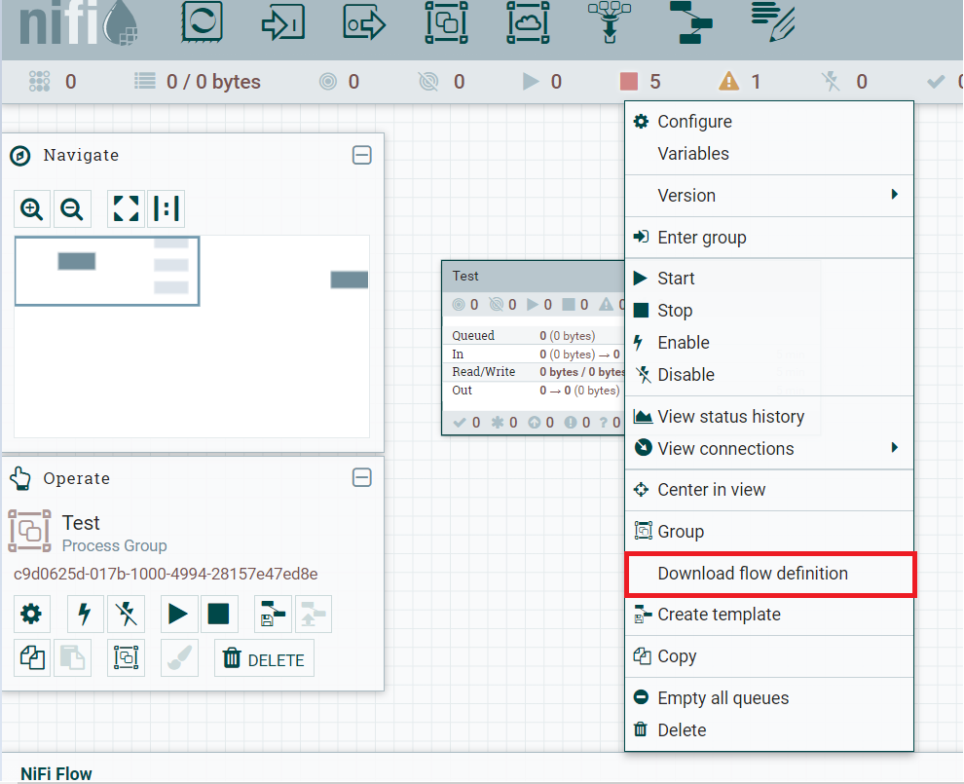

*Note: If "Download flow definition" is selected for a versioned process group, there is no versioning information in the download. In other words, the resulting contents of the JSON file is the same whether the process group is versioned or not.*

* **Importing a Process Group**
* **Create a Bucket**
* A bucket is needed in our registry to store and organize NiFi dataflows. To create one, select the Settings icon (Settings Icon)in the top right corner of the screen. In the Buckets window, select the "NEW BUCKET" button.

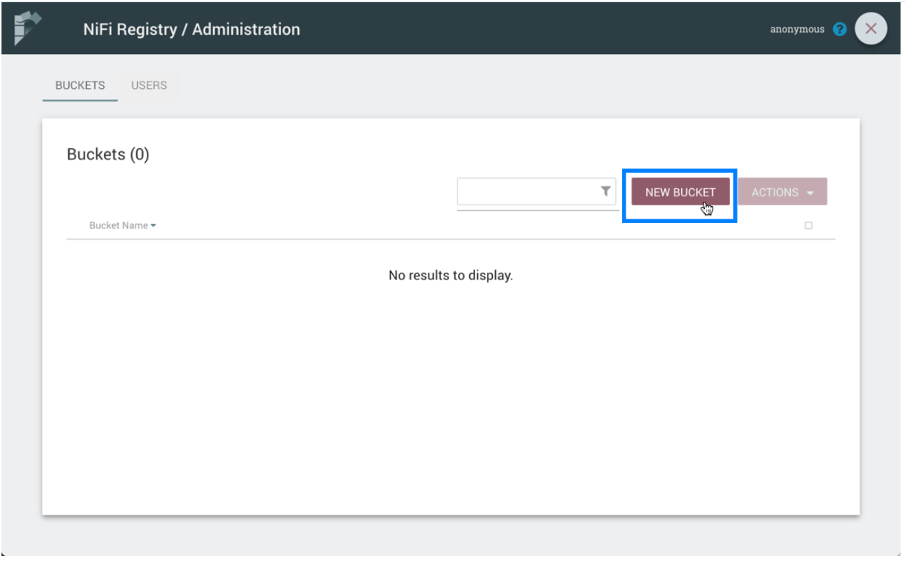

* Enter the bucket name "Test" and select the "Create" button.

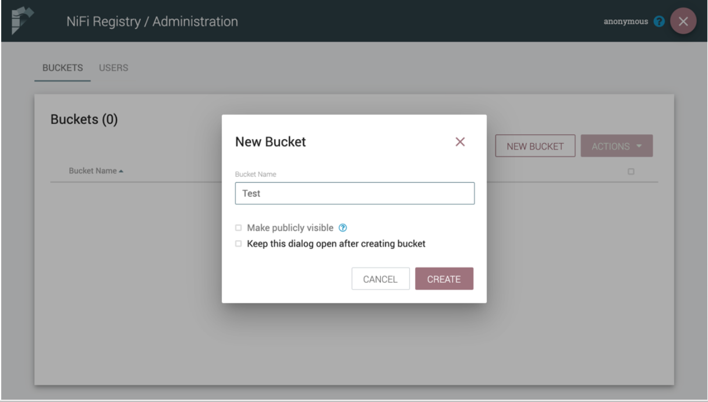

* The "Test" bucket is created:

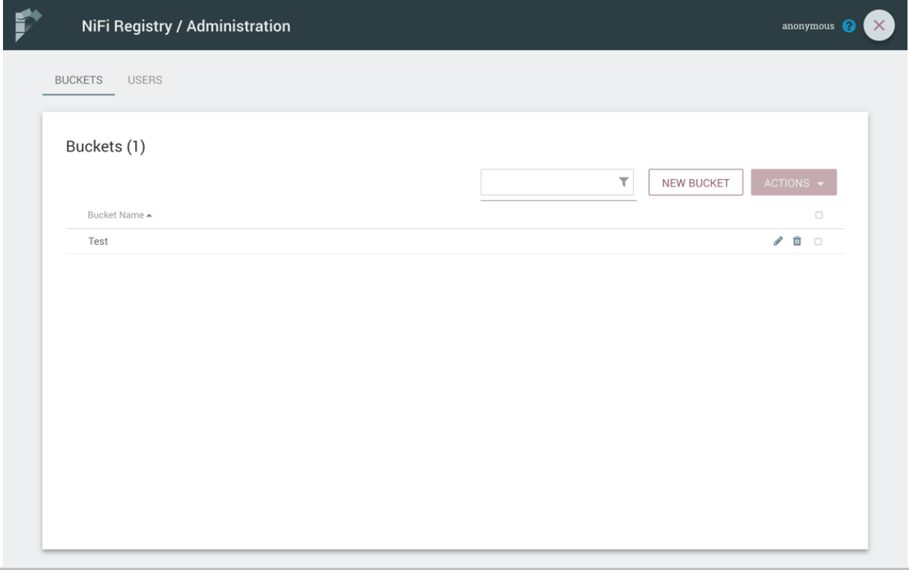

* **Import New Flow**
* To import new flow, select the "IMPORT NEW FLOW" button.

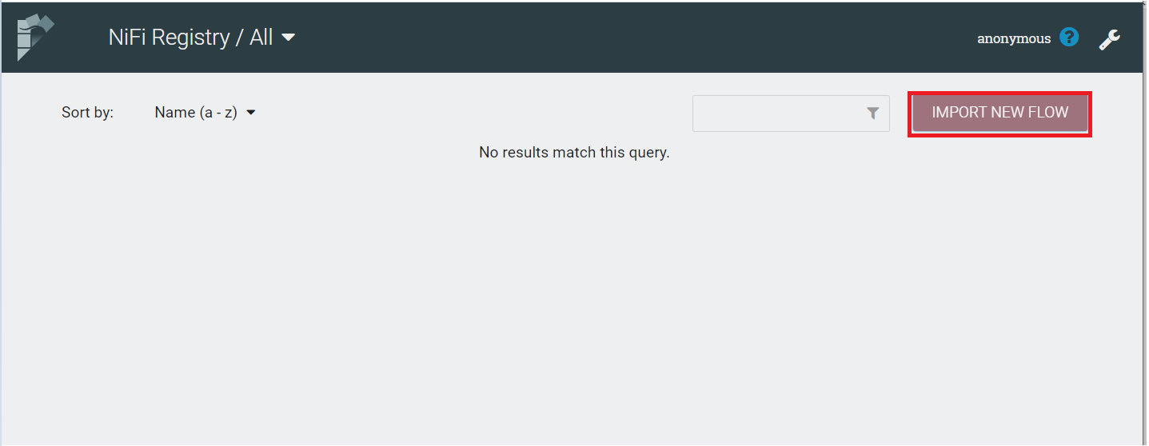

* Enter the Flow name, Flow description, choose Bucket and select “SELECT FILE” button to choose which json file to upload. Select the file and click Open. Finally, select the "IMPORT" button.

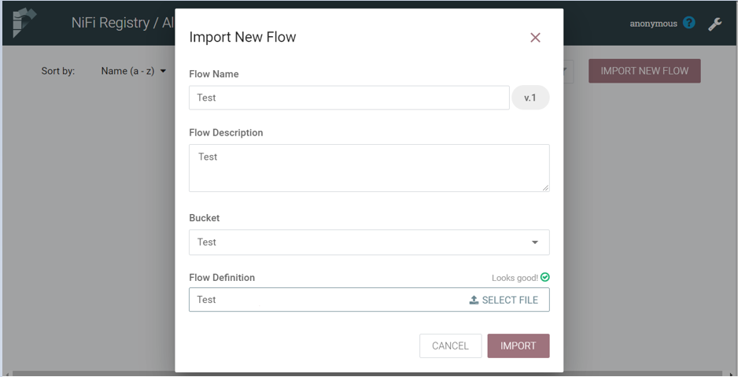

* The "Test" Flow is imported:

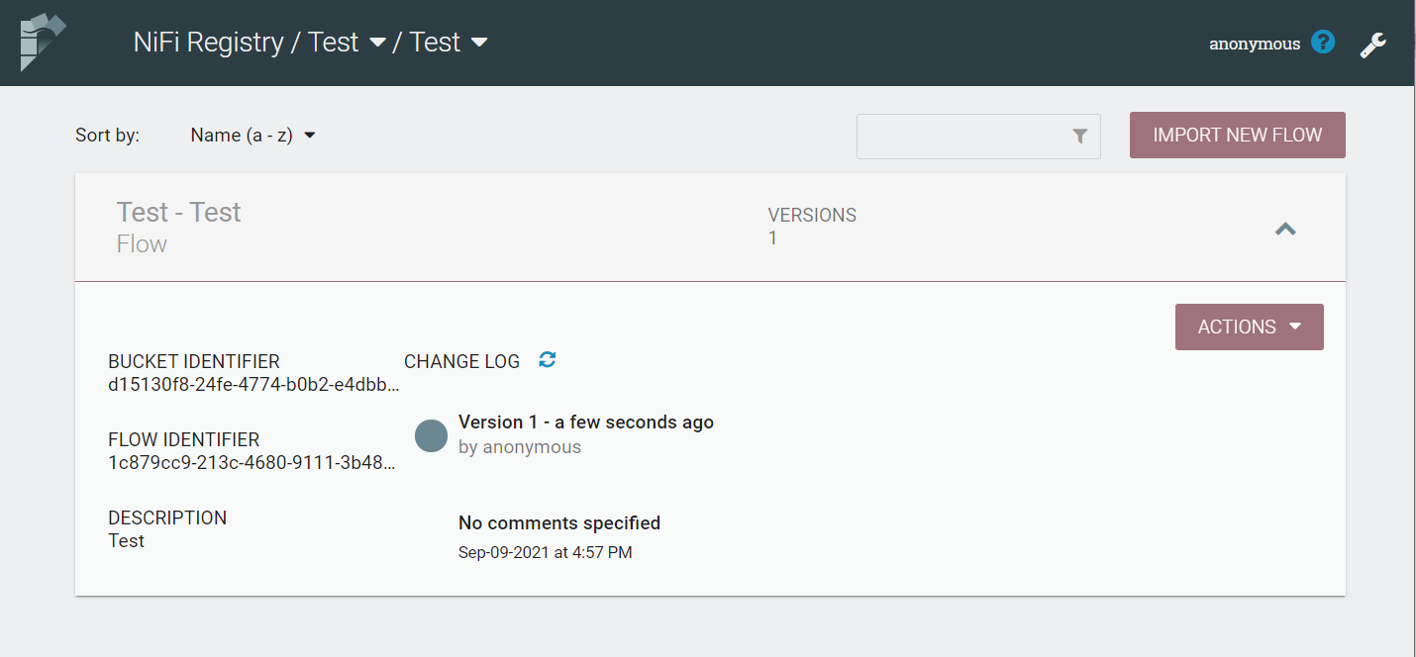

* **Connect NiFi to the Registry**
* Now it is time to tell NiFi about the local registry instance.
* Start a NiFi instance if one isn’t already running and bring up the UI. Go to controller settings from the top-right menu:

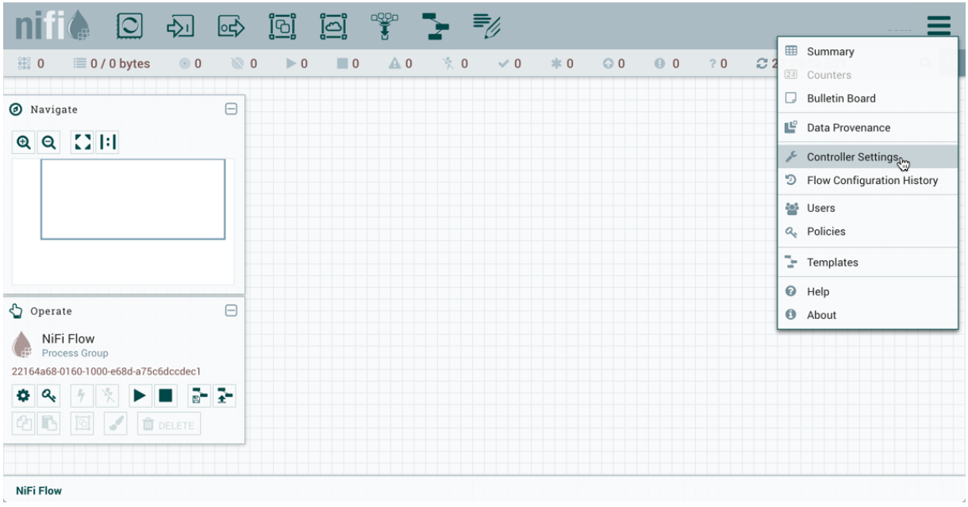

* Select the Registry Clients tab and add a new Registry Client giving it a name and the URL of [http://localhost:18080](http://localhost:18080/):

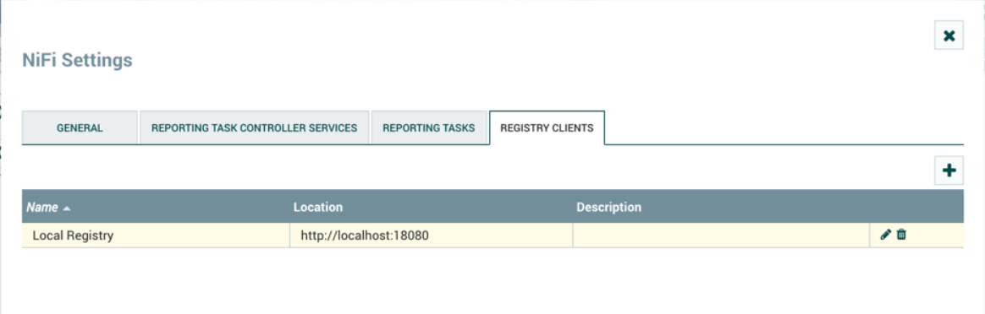

* **Import a Versioned Flow to NiFi**
* With a flow existing in the registry, we can use it to illustrate how to import a versioned process group.
* In NiFi, select Process Group from the Components toolbar and drag it onto the canvas:

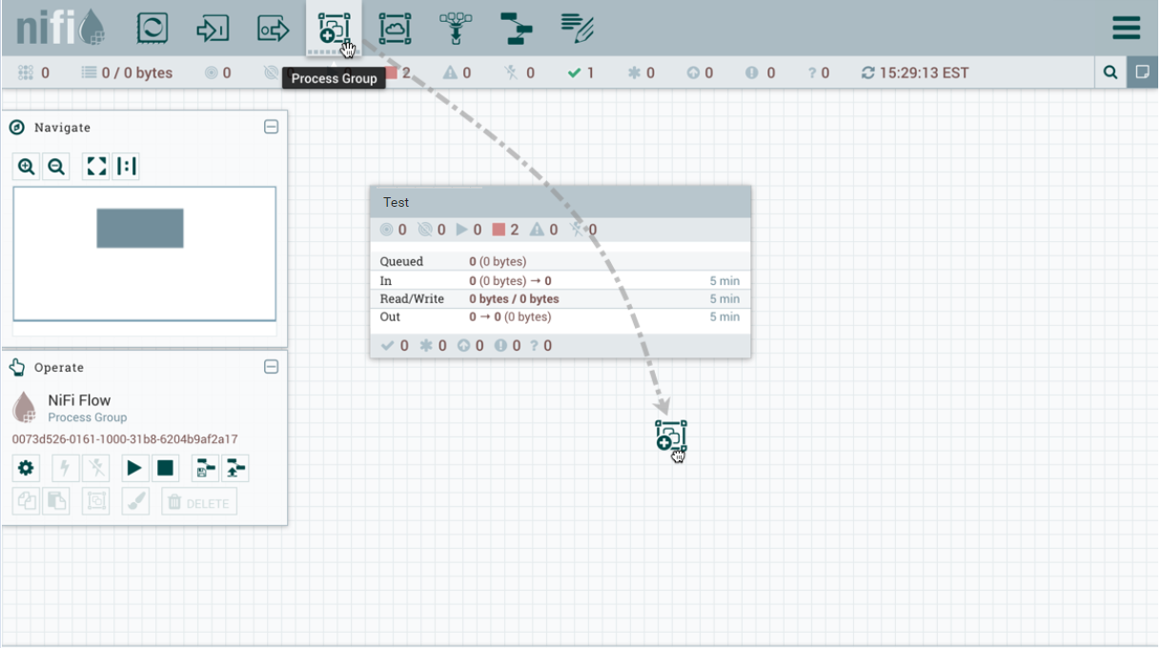

* Instead of entering a name, click the Import link:

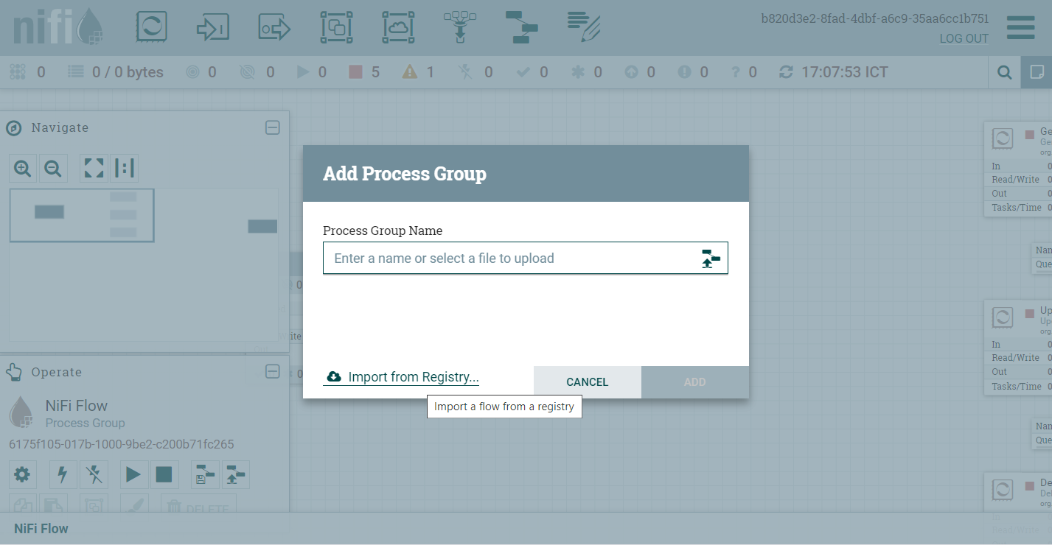

* Choose the version of the flow you want imported and select "Import":

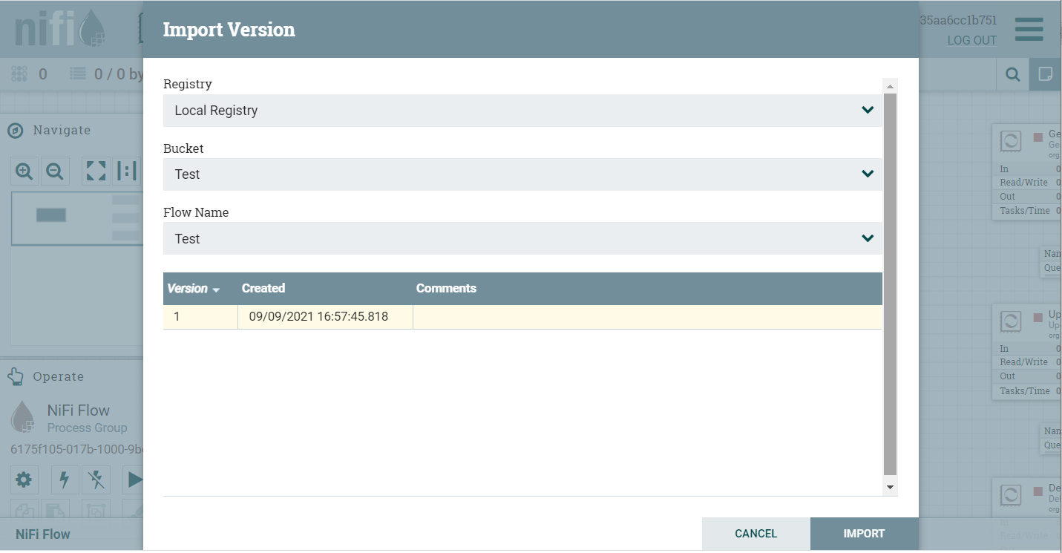

1. **Case 2**

* Detailed guide at this link: <https://nifi.apache.org/docs/nifi-registry-docs/index.html>

# **Reference**

[**https://nifi.apache.org/docs/nifi-docs/html/user-guide.html#templates**](https://nifi.apache.org/docs/nifi-docs/html/user-guide.html#templates)

[**https://nifi.apache.org/docs/nifi-registry-docs/index.html**](https://nifi.apache.org/docs/nifi-registry-docs/index.html)